Week 1 - Day 2: The FloCard Ecosystem & Platform Architecture

1. Enterprise Infrastructure: Strategic Web Assets Exploration

Key Takeaways from 366Pi Technologies

Website - https://366pi.tech
- Sustainability & Tech Integration: 366Pi specializes in building bespoke digital solutions that seamlessly integrate advanced modern technology (such as cloud architectures and blockchain frameworks) with Corporate Social Responsibility (CSR) and ESG governance tools.
- Outsourced Innovation Engine: The firm operates as an enterprise-grade digital transformation partner and an outsourced innovation lab for high-risk heavy industries, building robust real-time tracking pipelines and operational web assets.
- Agile Operational Delivery: Guided by strong technical mentorship, 366Pi focuses on shifting fragmented, legacy business operations into scalable, automated, and secure digital workflows using environments like Microsoft Azure and robust data engineering.

Key Takeaways from FloCard

Website - https://flocard.app
- Zero-Waste Networking Asset: FloCard completely reimagines identity exchange by transforming paper-based business cards into clean, secure, and dynamic digital card profiles shared via QR codes or deep links.
- Blockchain-Backed Trust Layer: The platform utilizes blockchain networks as an auditable digital ledger to verify user identities, track interactions securely, and protect professional connection data.
- Direct Value Realization Ecosystem: FloCard links physical networking actions directly to tangible environmental contributions, transforming standard corporate interactions into real-world sustainability outcomes through automated backend modules.

2. Professional Identity Architecture: FloCard Deployment
To fully engage with the core platform, I successfully finalized the setup of my digital professional profile within the staging and production infrastructure.

Implementation Ledger
- Credential Provisioning: Set up a secure login identity on the platform, establishing a clean, unified identity placeholder.
- Metadata Enrichment: Inputted full personal and academic/professional data arrays, mapping out relevant skills, contact nodes, and technical projects into a scannable identity profile.
- Peer Network Initialization: Initiated live identity exchanges with three engineering team members, testing the platform's cross-sharing mechanisms, data-writing speeds, and instant backend synchronization.
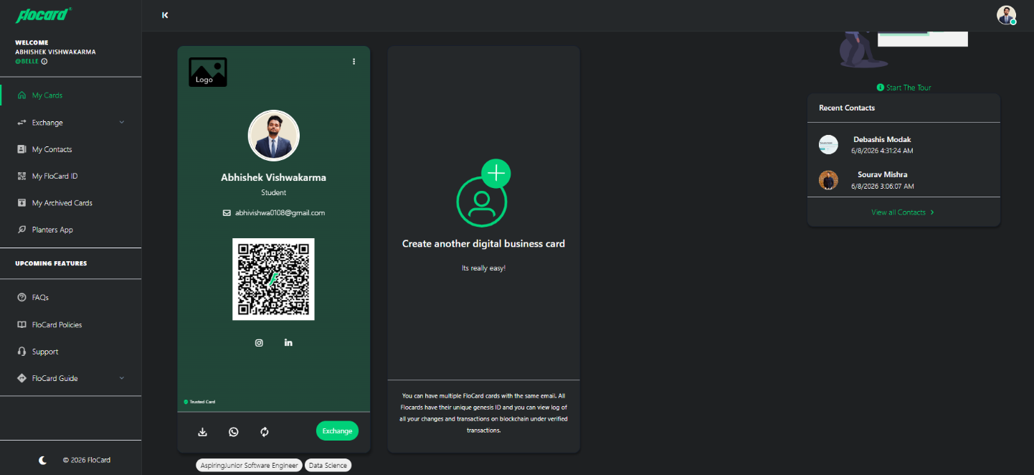

3. Structural Mapping: The FloCard Ecosystem Flow
The platform coordinates identity verification and operational metrics across three distinct system flows:
┌────────────────────────────────────────┐
│ The FloCard Ecosystem │
└───────────────────┬────────────────────┘
│
┌─────────────────────────┼─────────────────────────┐
▼ ▼ ▼
[Tree Planters Flow]
Tag Ledger -> Spatial Verify
[Communities Flow]
Org Control -> Audit Network
[Individuals Flow]
Profile Link -> Sync Identity

Individuals Flow
The user journey for individuals begins with profile instantiation and credential mapping. Users securely log into the platform, update their professional details, and generate a dynamic digital card anchored to a unique sharing token. When encountering a contact, the card is rendered via a QR code or an access link; the recipient scans the image, enabling instant data transmission. The backend engine writes this exchange record securely to a localized ledger, immediately updating both users' network maps without relying on physical printing media or manual database tracking.

Communities Flow
The communities’ workflow provides centralized governance and administrative control for groups, academic institutions, and enterprise departments. Administrators create a unified corporate or group workspace on the platform, establishing global branding standards and permission-locked profile templates for all underlying participants. As community members actively swap identity profiles, the system aggregates transaction volumes and networking data into a secure central control board, allowing enterprise officers to audit connectivity trends, measure collective interaction metrics, and seamlessly verify corporate alignments.

Tree Planters Flow
The Tree Planters track serves as the data validation engine that bridges digital data footprints with real-world ecological restoration. When a corporate organization funds an environmental initiative, the platform registers the deployment to a distributed digital ledger. Field agents and farm managers utilize dedicated mobile screens to record and tag vital tree metrics, logging specific planting coordinates, timeline dates, and growth states. This tracking data cascades into an auditable spatial log, converting abstract green pledges into verifiable environmental data points that can be inspected by external stakeholders.

